Flow chart of expense Tracker and budget Optimizer
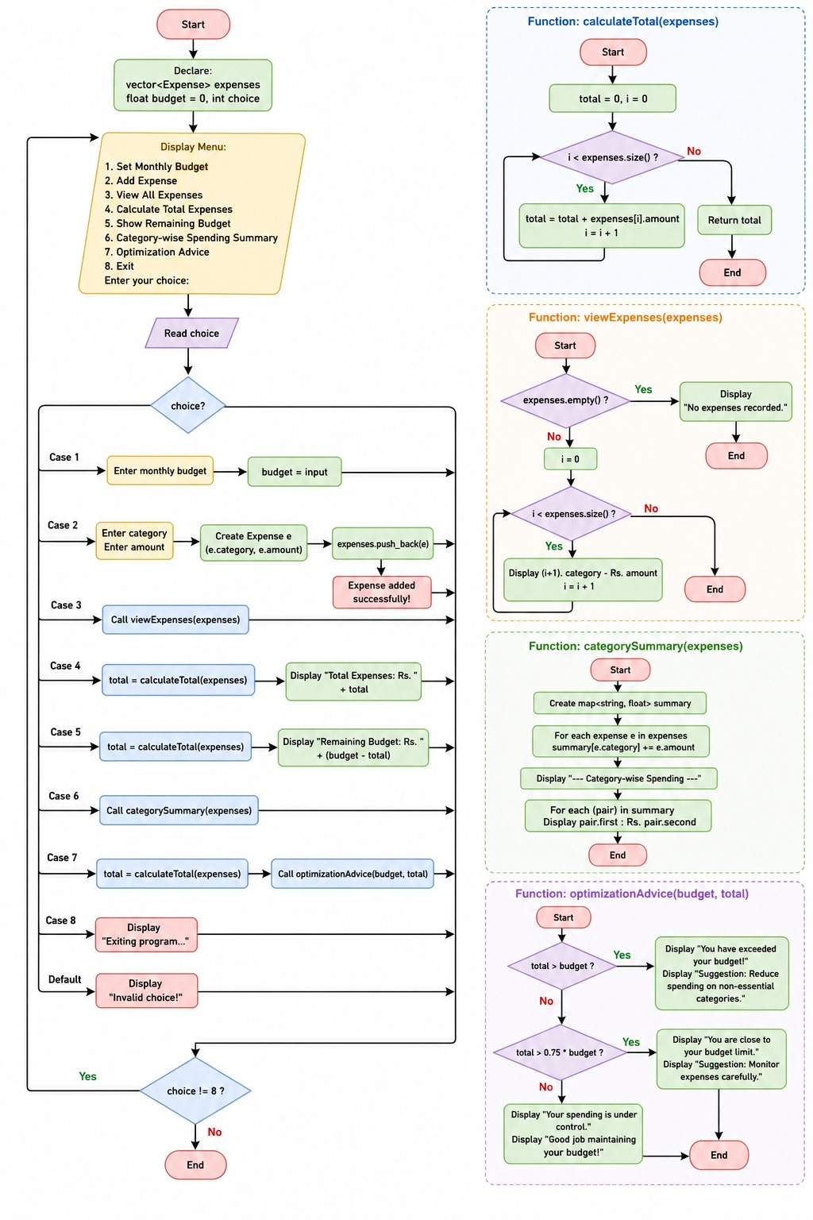
Algorithm for expense Tracker and budget Optimizer

🔹 Step 1: Start the Program
🔹 Step 2: Initialize
- Create an empty list called expenses
- Set budget = 0
🔹 Step 3: Show Menu
Display the following options:
1. Set Monthly Budget
2. Add Expense
3. View All Expenses
4. Calculate Total Expenses
5. Show Remaining Budget
6. Category-wise Summary
7. Optimization Advice
8. Exit
🔹 Step 4: Take User Choice
🔹 Step 5: Perform Operation Based on Choice
➤ If choice = 1 (Set Budget)
- Ask user to enter budget
- Store it in budget
➤ If choice = 2 (Add Expense)
- Ask user to enter:
- Category
- Amount
- Create a new expense record
- Add it to expenses list
➤ If choice = 3 (View Expenses)
- If expenses list is empty:
- Show “No expenses recorded”
- Else:
- Display all expenses with category and amount
➤ If choice = 4 (Calculate Total)
- Set total = 0
- For each expense in list:
- Add amount to total
- Display total expenses
➤ If choice = 5 (Remaining Budget)
- Calculate total expenses
- Remaining = Budget – Total
- Display remaining amount
➤ If choice = 6 (Category-wise Summary)
- Create a map (category → total amount)
- For each expense:
- Add amount to its category
- Display category-wise totals
➤ If choice = 7 (Optimization Advice)
- Calculate total expenses
- If total > budget:
- Show “Budget exceeded” + suggestion
- Else if total > 75% of budget:
- Show warning message
- Else:
- Show “Spending under control”
➤ If choice = 8 (Exit)
- Stop the program
➤ If invalid choice
- Show “Invalid choice”
🔹 Step 6: Repeat
- Repeat steps from Step 3 until user selects Exit
🔹 Step 7: End Program

